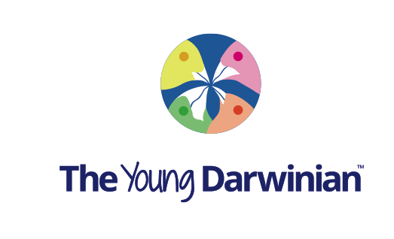
www.theyoungdarwinian.com
Registration form for students
Please fill in this form and email us back to info@theyoungdarwinian.
First name:

Last name:

Gender:

Date of birth:

School name and address:

Country:

email:

Comments:

I agree that this information can be used by The Young Darwinian. I understand that my first name, school name and country may appear on the web site, and in the journal, both electronic and print. I also understand that this information will be kept confidential by The Young Darwinian, and will not be sold or given to a third party.

Print full name or sign to agree:

Date:

If you are under 18 please ask a parent or guardian to fill in this:

I am parent/guardian of the above student. I agree to the terms outlined above:

Print full name or sign to agree:

Email address of parent/guardian:

Once you have returned this form to us, student and parent/guardian will both receive an email that will ask for confirmation these details are correct.

Professor Anthony K. Campbell, Editor in Chief, The Young Darwinian, 01/04/2017.

