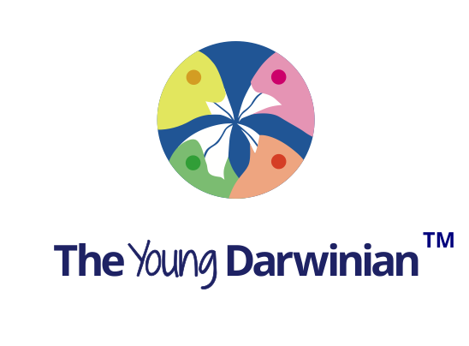
Registration

First name:

Surname:

Other names:

Email:

The Young Darwinian will email you once we receive your registration. Your email address will appear on any articles you write only if you request this. The Young Darwinian undertakes to use you email address only for The Young Darwinian purposes, and not to give or sell your email address to another party.

Professor Anthony K Campbell
Editor in Chief
The Young Darwinian
tony@theyoungdarwinian.com
04/08/2017

