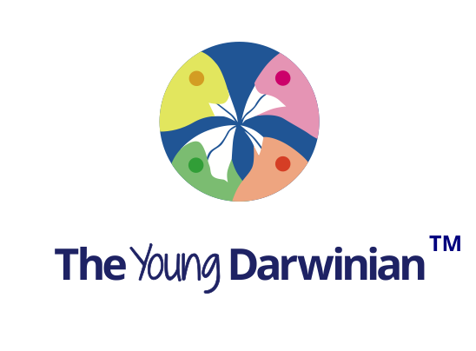
Full name, with title and qualifications:
Affiliation/address:
Email:
Key words (up to six):
How did you discover that you were a scientist, engineer or mathematician?
Please just fill in the answers, and add more text if you wish! We are aiming at High School age. We suggest articles up to 1000 words. Thanks for your support.
Please email your form to info@theyoungdarwinian.com
Ten key questions
1. What made you curious when you were young, and did you have any heroes who influenced you? For example, Is there a person, place, event or moment that influenced or changed your way of thinking?

2. When and why did you decide to choose science/maths/engineering as a career, particularly what or who inspired you? Did you have any family connections to STEM careers?

3. Where did you grow up, and what was your educational path?

4. How has your career developed after university, and how was it funded?

5. Have you had any break-though moments in your research, if so what were they and how did they affect your development?

6. What do you regard as your most important discoveries and inventions, and why?

7. Can you think of anything that could have done better, and do you have any regrets?

8. What other stories do you have about your curious life, including any entrepreneurial and commercial activities, and your other interests?

9. List six key publications (not necessarily yours), and explain why you have chosen them?

10. What advice would you give a curious young mind? Imagine your ten year old self, if you started again! Is there a big unanswered question today?

