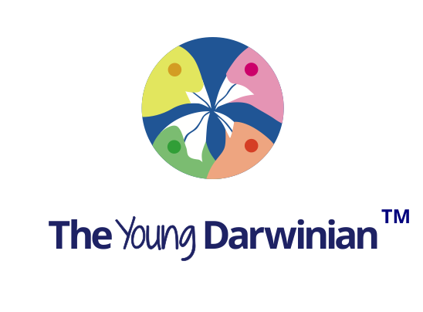

Science News

The latest scientific and medical advance will be posted on this site. Let us know what you have heard of, or seen on the TV, newspapers or Internet. And tell us what has inspired you. We will post it on this web site. Email us at info@theyoungdarwinian.com.

1. The amazing heroine bite of the small, Pacific fang-blenny reef fish, Meiacanthus nigrolineatus.
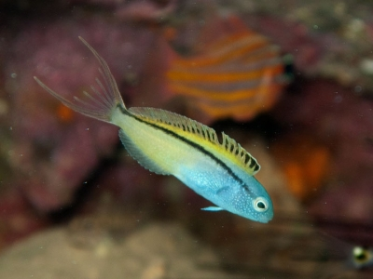
© Stig Sarre
This is an amazing story about a small fish that has just been published. When it bites, you can't feel it. This is because it makes a toxin like heroin. Quite a fix! Many marine animals make extraordinary toxins - jellyfish, snails, octopus, and fish for example. Tetrodoxin, made by bacteria that grow in puffer fish and some octopus, is one of the most potent toxins known. It stops nerves working. Then, there are the Conus sea snails, that have a harpoon that spears prey or predators with toxin. One of these have even been use to develop a drug for use in humans. Nature knows best, as Darwin and Wallace told us.
Read more at http://DOI: http://dx.doi.org/10.1016/j.cub.2017.02.067

2. The NASA space probe Cassini sends back amazing information about one of Saturn’s moons.
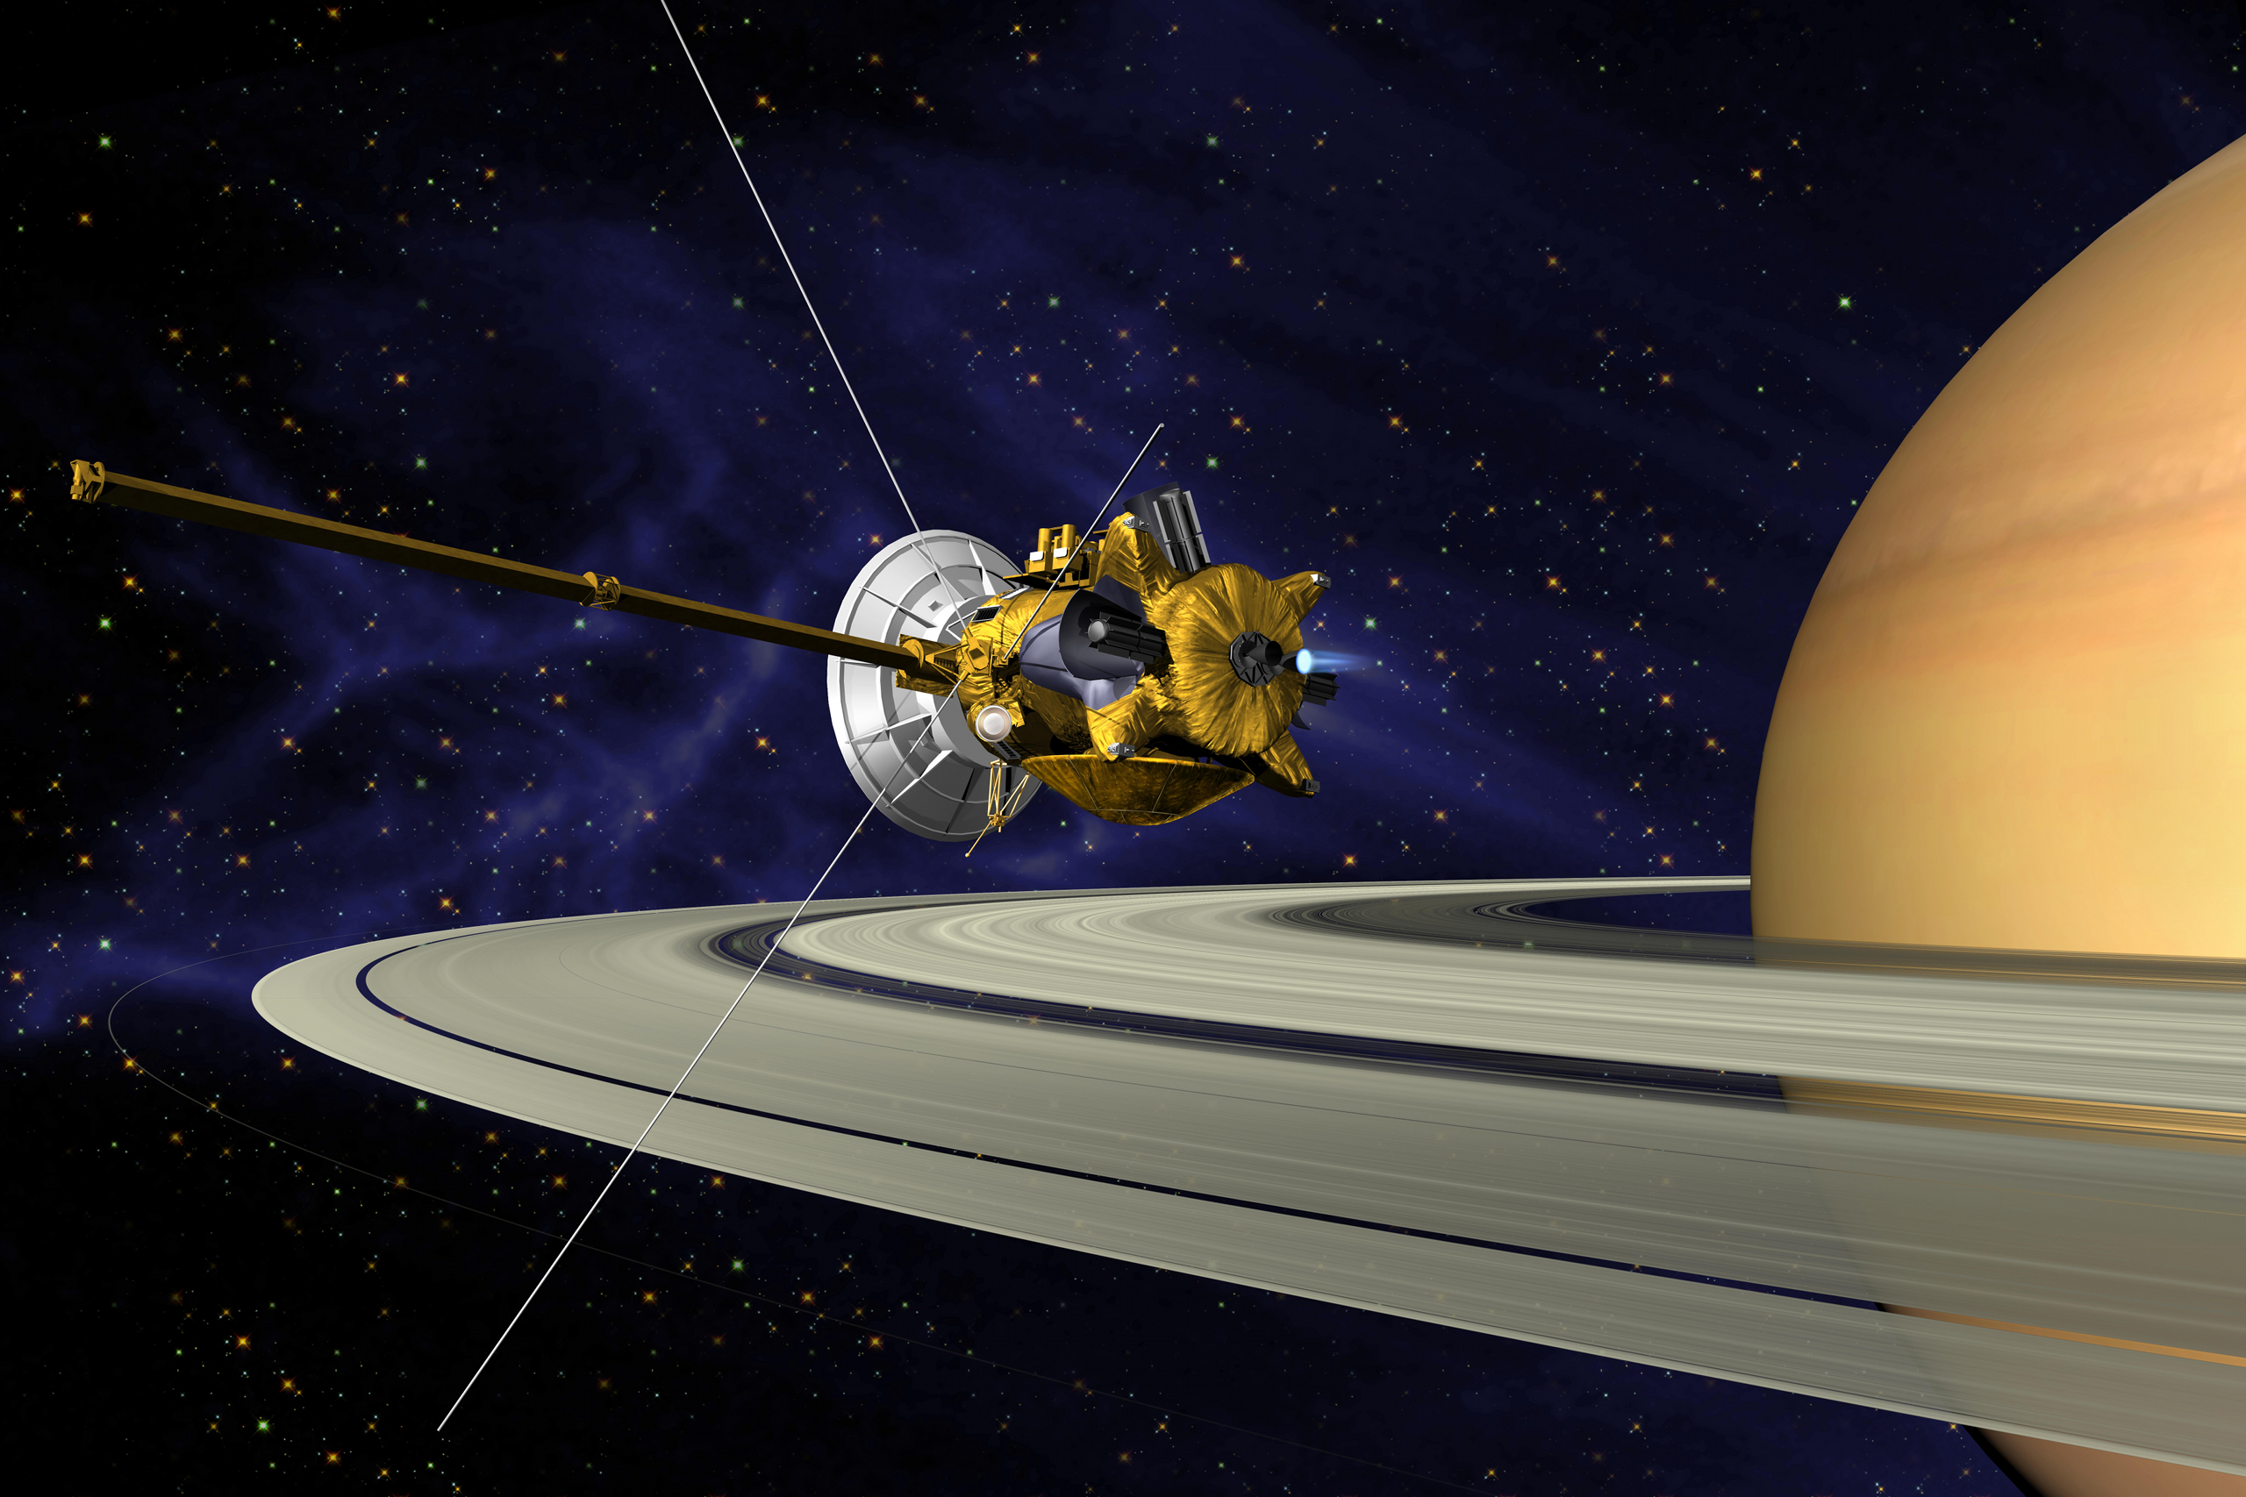
Cassini was launched from Earth 20 years ago in 1997, and has been orbiting Saturn for the last 13 years. It has recently discovered that one small moon – Enceladus – is releasing hydrogen gas from an underwater volcanic vent. This could provide energy for microbial life. If this is happening then it would add evidence for the Panspermia hypothesis that life on Earth, in fact, originated somewhere else. The amazing findings about Enceladus is published by Waite et al in Science vol. 356, 155 - 159, April 14th 2017 entitled ‘Cassini Finds Molecular Hydrogen in the Enceladus Plume: Evidence for Hydrothermal Processes’. https//DOI: 10.1126/science.aai8703
Read more at: https://phys.org/news/2017-04-scientists-evidence-habitable-region-saturn.html#jCp

3. Memories are not what they used to be
Look out for this elegant research, which fundamentally changes the theories of memory formation, and its long-term storage. Until now, it has been thought that memory of an experience is formed in our short-term memory in the hippocampus of the brain, and then gradually transferred to the cortex for long-term storage. This research shows this is not so. The stimulus given was a small electric shock, and therefore provoked a ‘fear’ memory. The cells stored this memory in the brain, called engrams, are formed in the cortex at the same time as in the hippocampus, and mature over the next few weeks. This memory developed, and was retained, in the amygdala. The amygdala is one of two almond-shaped groups of nuclei located deep and medially within the temporal lobes of the brain. It processes memory, decision-making, and emotional reactions. This research was carried out on mice. But it is expected that the same mechanisms are happening in the human brain. The potential consequences of this discovery for people with post-traumatic amnesia, and short-term memory loss, are very exciting.
Read more: Engrams and circuits crucial for systems consolidation of a memory (2017). Takashi Kitamura, Sachie K. Ogawa, Dheeraj S. Roy, Teruhiro Okuyama, Mark D. Morrissey, Lillian M. Smith, Roger L. Redondo, and Susumu Tonegawa. Science 07 Apr 2017, Vol. 356, Issue 6333, pp. 73-78.
DOI: 10.1126/science.aam6808.

3. Personal water
A truly life changing invention has been developed between scientists at MIT and the University of California at Berkeley. They have made a ‘machine’ that has no moving parts. It requires only solar heat to run, and can extract drinking quality water from arid desert air. As the world is getting hotter and the population is increasing, this is a very timely invention. The clever part was invented 20 years ago by a professor of chemistry, Omar Yaghi. The mechanism that absorbs the water is called a MOF - metal-organic framework. This has a sponge like consistency, and by changing the metal and organic component can be made hydrophilic. By painting the surface black to absorb the solar heat, and keeping the other side, away from the sun, at ambient temperature, the water vapour formed is driven to drip into a collecting vessel. It takes a MOF of about a kilogram to produce enough water for one person for a day. Personal water!! MIT = Massachusetts Institute of Technology, Cambridge MA
Read more Hyunho Kim, Sungwoo Yang, Sameer R. Rao, Shankar Narayanan, Eugene A. Kapustin, Hiroyasu Furukawa, Ari S. Umans, Omar M. Yaghi, and Evelyn N. Wang (2017). Water harvesting from air with metal-organic frameworks powered by natural sunlight. Science 13 Apr 2017: eaam8743;. DOI: 10.1126/science.aam8743

Last updated: 15/05/2017

