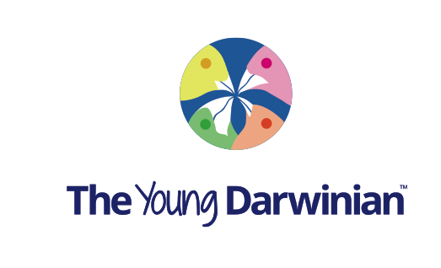
www.theyoungdarwinian.com
Registration form for students
Please fill in this form and email us back to info@theyoungdarwinian.
First name:

Last name:

Gender:

Date of birth:

Country:

email:

Comments:

Professor Anthony K. Campbell
Editor in Chief, The Young Darwinian

